Changing WB service from dynamic to static IP (Enterprise Service)

Reprovision the WB and go to the SVT page and get the static ip of the newly provisioned system. Click on the View link at the bottom of the third column in the SVT page shown below:
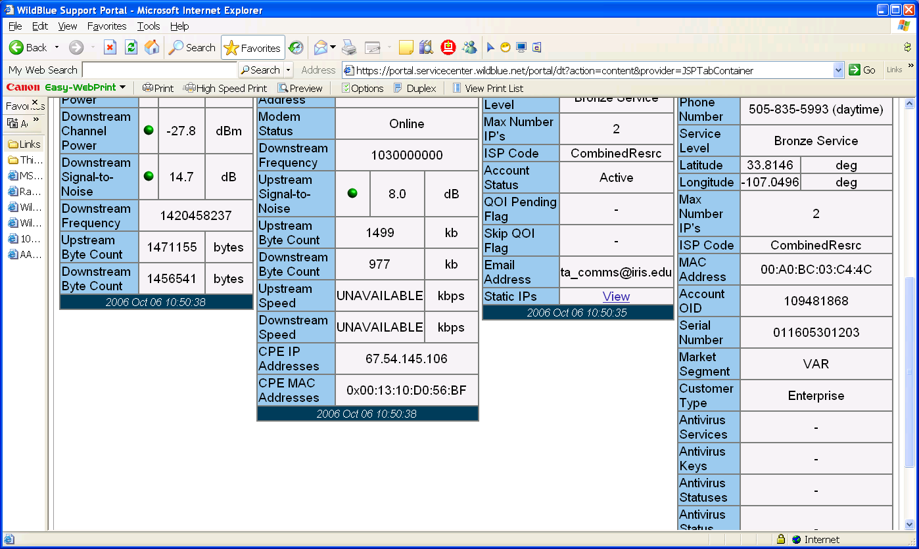

This gives you the following window:
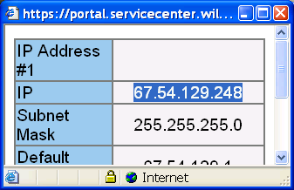

Copy and paste the IP address.
Now open another browser and go to ip: 192.168.33.1
Login: Password: taops
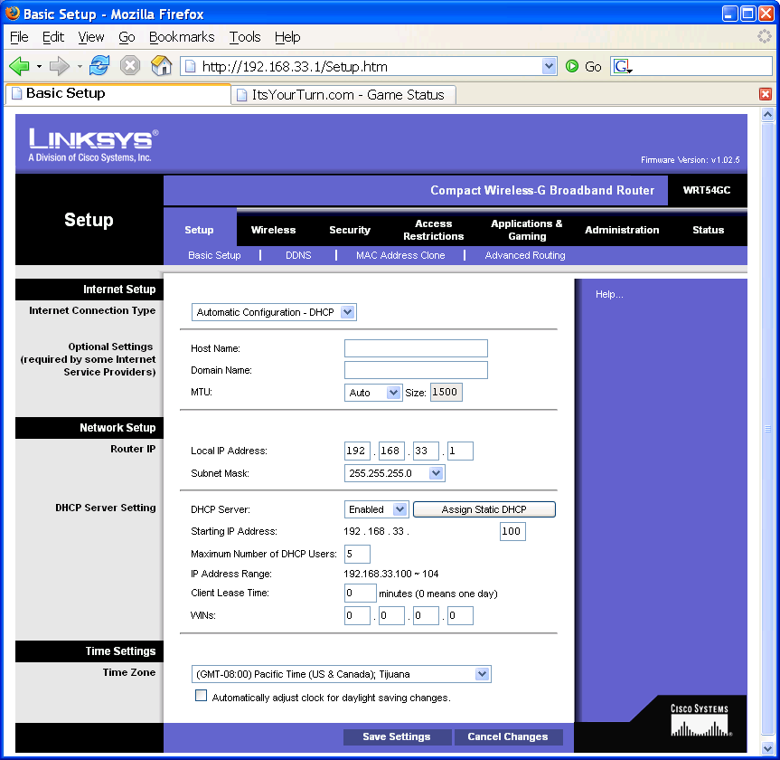

On the page shown (Setup: Basic Setup) click on the arrow to the right of where it says:
“Automatic Configuration – DHCP”
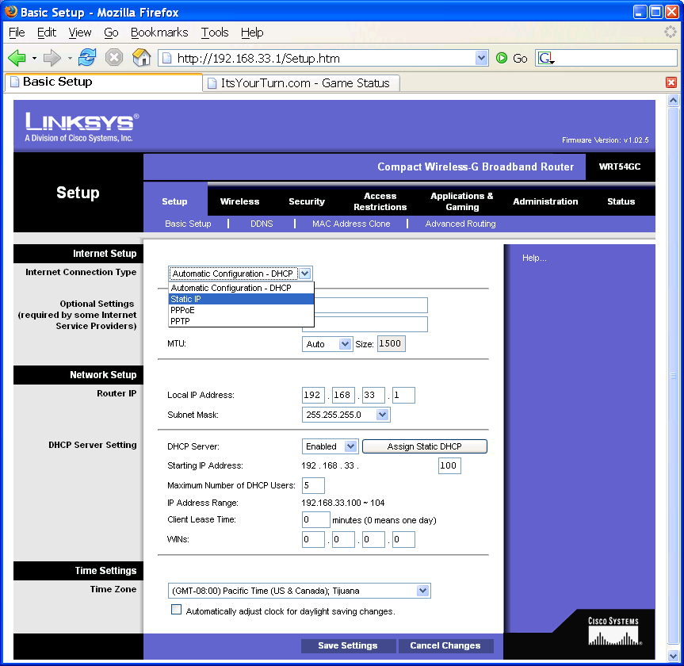

Choose Static IP and enter the information from the WB View box:
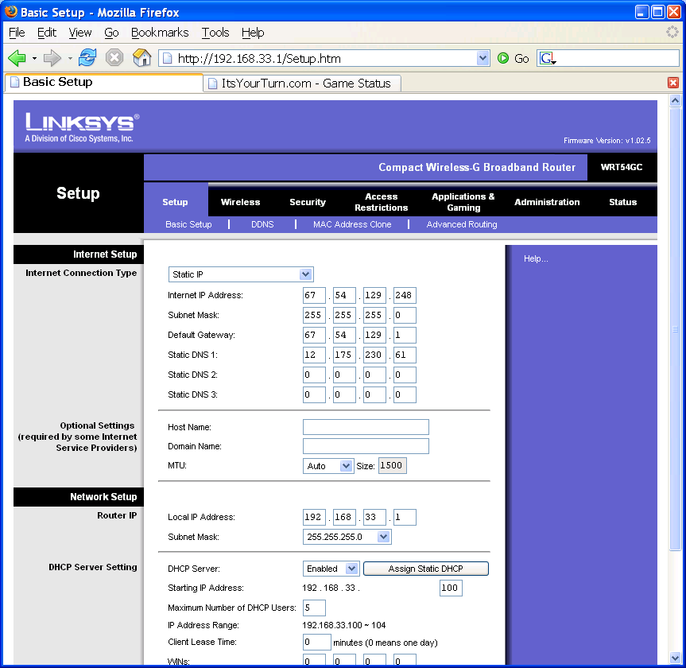

Click on “Save Settings” at the bottom of the page. It will ask you to reenter the taops password

