How to update the Q330 s/n and IP in Willard

20070213 (rev 1.1 aws)
20090617 (rev 1.2 aws – authorization code removed for public access)

When swapping a Q330 it is necessary to update the Willard config file for the station in question so that Willard can reconnect. Also, some stations will have their IP change for various reasons. This document describes how to use Willard to update these values so that Willard can link again to the station. For this example we will use station C05A as it is presently (2007 – Feb) configured.

The new Q330 s/n: 0100000B652695D3
The present IP: 156.74.77.26

1)With the IP on the internet, open Willard:
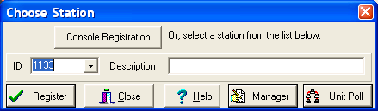

2) Click on the “Manager” button to get:
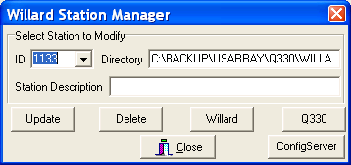

3) If you’ve already connected to the station (e.g. C05A), find it in the ID selection list and click on it:
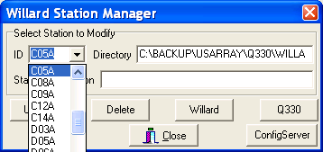
Then click on the “Q330” button and go to step 6. You will be in the same window: Q330 Configuration for C05A, only there will already be values in the boxes (Ethernet value and Q330 Serial Number)

4) If you have not connected previously to C05A, type C05A into the ID selection area:
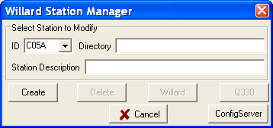

5) Click on the “Create” button and you will go to:

6)
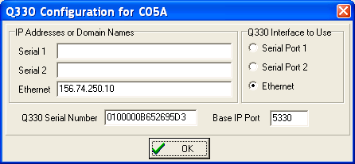

In this example the Q330 Serial Number and Ethernet IP are already up to date. If they need to be changed, or are blank because C05A has not been connected to yet, click the cursor in the area where they are displayed and use backspace and type in the new values.

7) Once finished and checked, click Ok.
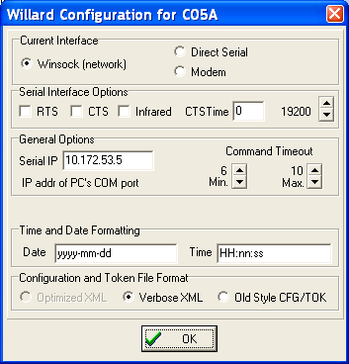
8) click ok again
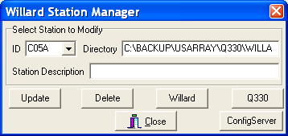

9) and click “Close”.

10) Now Willard should be able to connect to C05A ( you may have to type in the authorization password if it has been erased by this process.

