Communicating with a TA station Q330 Remotely Using Willard
20090617 authorization code removed for public access - aws
- Connect your PC to the internet and make sure you can get to various web pages.
- Open Willard and click on Manager: 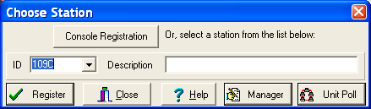

- Click on ConfigServer:
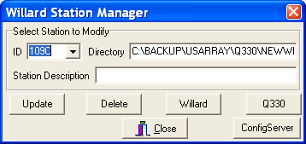

- Click on Choose:
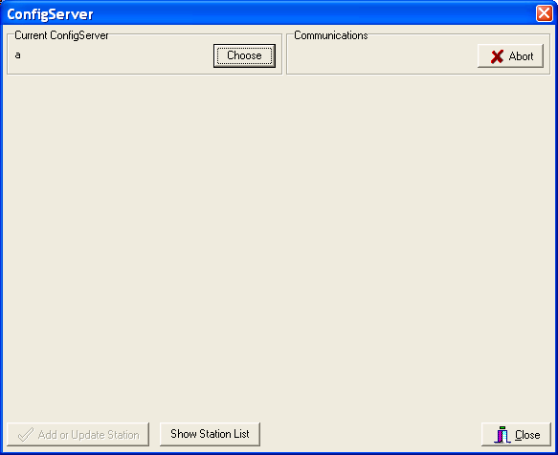

- Enter http://ta-config.isti.com:8133 into the Select Config Server and click OK

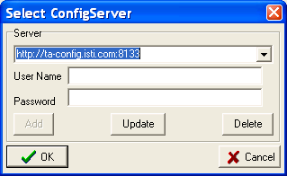

- Click on Show Station List:
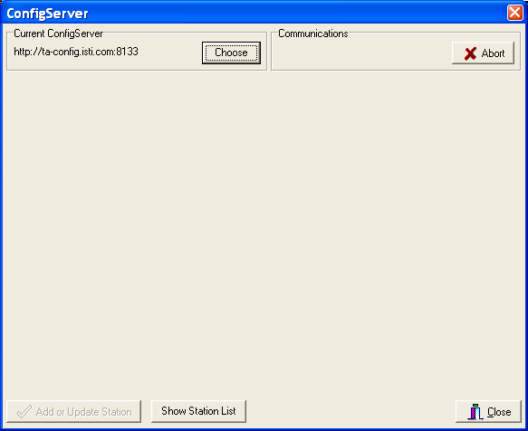

- A list of TA stations should appear. Click on the button above DP4 to get the list ordered:
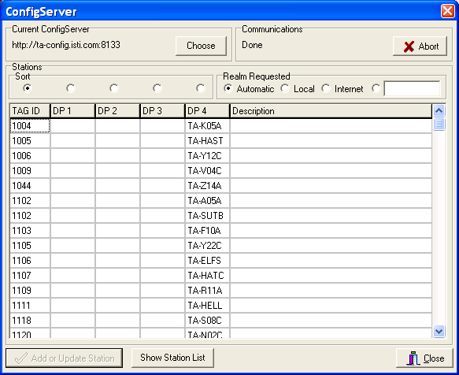

8) Scroll down until the station you wish to connect to appears and click on the station name under DP4:
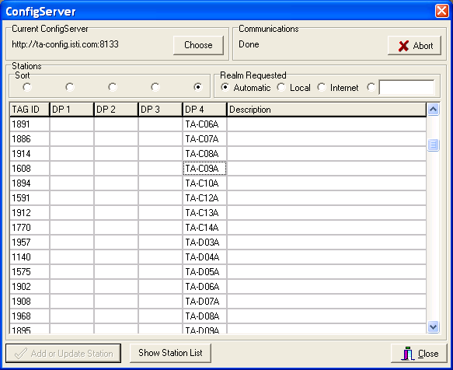

- Click on where it says Ethernet:

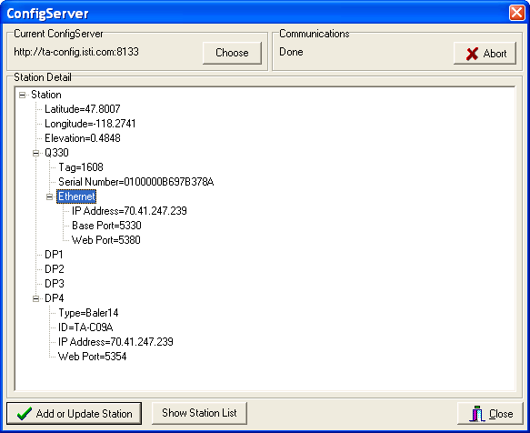
- Click on “Add or Update Station” above to get the following window:

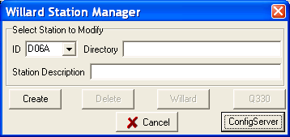

- Click Create above. Note: If you’ve already created this station in your Willard list, you will not get this box, but will jump to the next box:

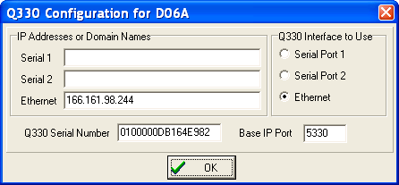

- Click OK:
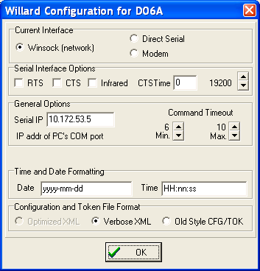

- Click OK again. Note: you will not get the above box, if you’ve already created this station in your Willard list, but will jump to the next box:

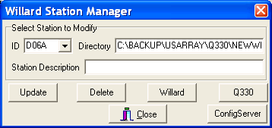

- Click Close above

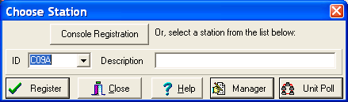

- Use the arrow and click on the station you want to connect to in the ID list. Click Register

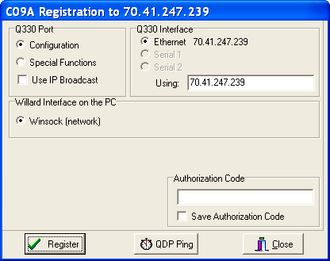

- Enter the Authorization Code (ask TA administrator for it), and click on Save Authorization code. Click Register.

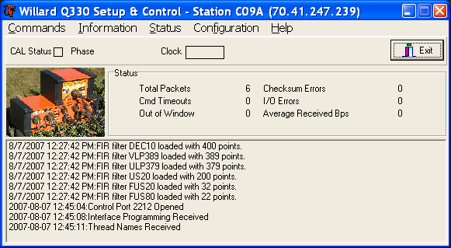

16) You should now connect to the remote Q330 station. Happy Willarding!

