TA Airlink Raven CDMA & EDGE Modems – Getting RSSI Levels from a Site

Version 1.1 aws (passwords removed for public document)
2009 06 17

1) The CMDA and EDGE modems can be connected remotely or through a PC serial port. This document will discuss how to get the RSSI (signal strength level) from a modem at a potential site.

2) Make sure the PC you are using has a serial port, or get a USB to Serial adaptor and install it and its driver on your PC.

3) Download the following files to the PC used to connect to the Airlink modems. They can be downloaded from the airlink site and then unzipped and installed:.

http://www.airlink.com/support/modems/utilities/ace.asp
Wireless Ace 3G Install and Net v1.1
Note: we now use the Ace Manager program, which handles the same functions as Wireless Ace. It can be found at www.sierrawireless.com/support - choose Raven X
radio, PC Windows operating system and unload it. Wherever it says Wireless Ace 3G below, substitute Ace Manager.

4) After Wireless Ace 3G and Net v1.1 are installed, attach the modem you are using to the PC’s serial port.

5) Start Wireless ace by clicking on its lightning rod icon. It can be used to connect to both Cingular EDGE and Verizon CDMA modems.

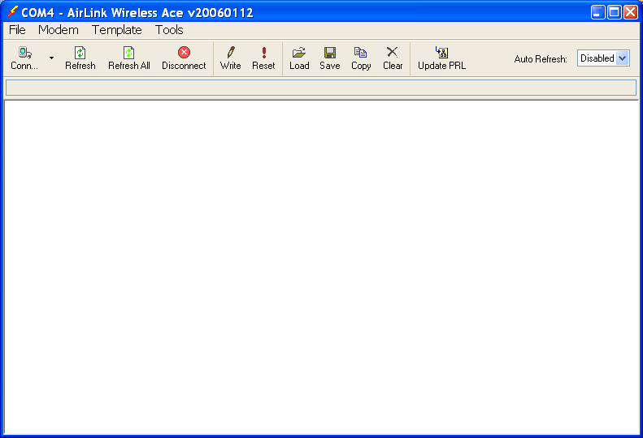

6) Click on “Conn” to begin. Choose PPP for the serial connection, and choose the Port you are connected to. If at first you don’t succeed, try the other COM ports. Set the password to the one supplied by the TA administrator:
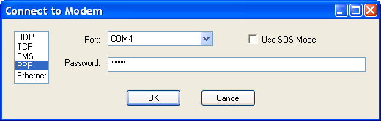

7) Example view of Wireless Ace 3G when connected to a modem (Raven EDGE in this case:
8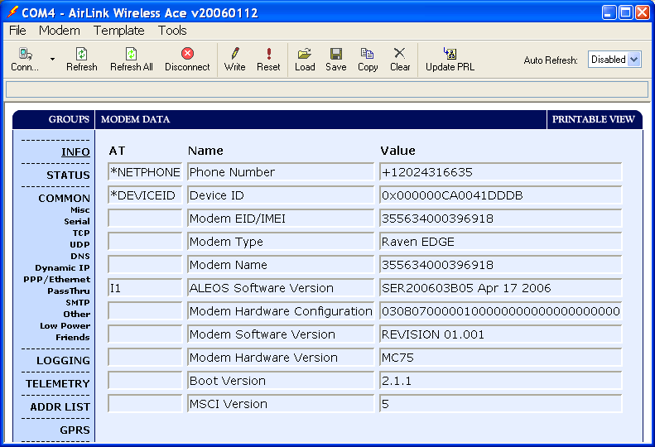

8) Click in the left column on the STATUS word under GROUPS. This will take you to the page where the RSSI information is shown:
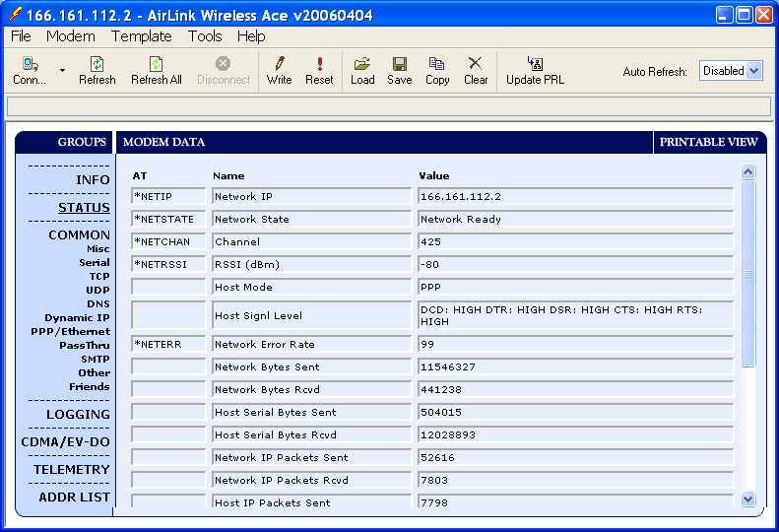

9) Looking at the 4th column down under Modem Data, you can see the heading NETRSSI, and the value is -80.

10) A rule of thumb is that as long as the absolute value of RSSI is less than 96, the site has good enough coverage for us to use. So a RSSI value of -95 is ok, as is -90, -85, -80 and so on, but a value of -100 is not good.

11) Hold down the left click button and pass the pointer across the text in the NETRSSI column to highlight it. Then click the right button and choose COPY. Paste this information into your Reconnaissance report, along with the GPS location you tested.

*NETRSSI | RSSI (dBm) | -80

