TA Airlink Raven CDMA & EDGE Modems – Updating Firmware and Configuration files

Version 1.0 rwb, updated aws
10/02/2006

1) The CMDA and EDGE modems can be programmed remotely or through a PC serial port. This document will discuss both methods.

2) Download the following files to the PC used to connect to the Airlink modems. They can be taken directly from the iDisk (User: ta_ops, select Public Folder, pwd: Tarray), or downloaded and unzipped from the airlink site.

iDisk: \Procedures\Airlink\Raven_software_release_20603B05\RavenCDMA_200603B05.exe
(this is latest firmware for the Verizon modems) \Procedures\Airlink\Raven_software_release_20603B05\RavenEDGE_200603B05.exe
(this is latest firmware for the Cingular modems)
\Procedures\Airlink\TA_cingular_rev5_060422.xml
(latest configuration file for the Cingular modems) \Procedures\Airlink\TA_VZW_dynIP_060531.xml
(latest configuration file for the Cingular modems) \Procedures\Airlink\wace-3g-v20060420.zip
(wireless ace tool for loading configuration files and checking
RSSI, etc)
www.airlink.com:
/support/modems/ravenCDMA.asp - click on “Latest Firmware version 200603B05”
(latest firmware for the Verizon modems)
/support/modems/ravenEDGE.asp - click on “Latest Firmware version 200603B05”
(latest firmware for the Cingular modems)
/products/ace.asp - click on “Download Wireless Ace”
(wireless ace tool for loading configuration files, checking
RSSI, etc)

Unzip the zipped files and run by double-clicking the icon of either the CDMA or EDGE version of the RAVEN***.exe file, depending on whether you are updating a Verizon or Cingular modem. For this document, we will run the RavenEDGE_200603B05.exe file and update a Cingular modem. It will find the RavenEDGE_200603B05.ini file in the same folder, if it exists.

If you are not sure whether the modem needs to be updated, the program Ace Manager provides status and version numbers from any online modem or through the serial port;

Select a modem – it can be the modem attached to the PC thru the serial port, in which you choose the PPP interface and the COM port connected to. Check with TA administrator for password:

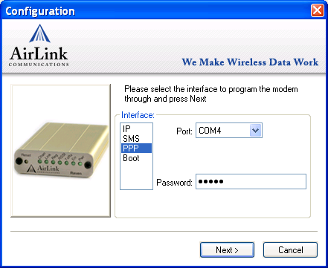

If the modem is to be connected to over the network, choose IP and enter the known IP ADDRESS. Note that you can (and we do) enter the ip address followed by a semi-colon station code to make it easier to identify the modem/station you’re working on.
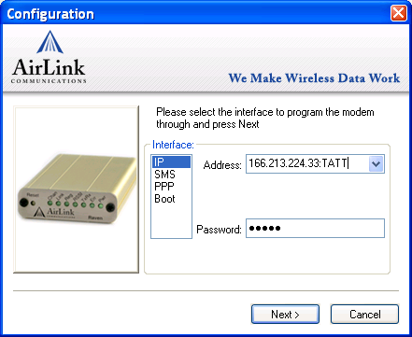
Click “Next” and the new firmware version will commence loading. This process takes several minutes by serial port – a bit faster by internet.

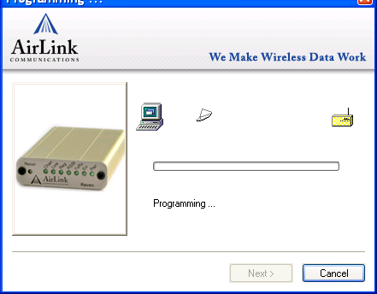

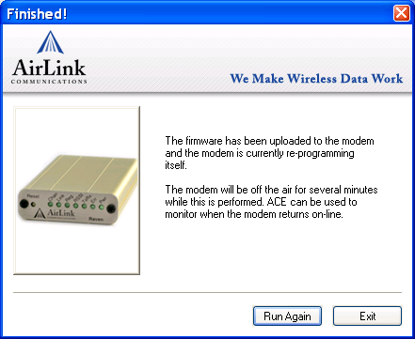

Next, Ace Manager is used to upgrade the configuration files and/or to look at settings in the modem, including RSSI level. Start Ace Manager by clicking on its lightning rod icon. It can be used to connect to both Cingular EDGE and Verizon CDMA modems.

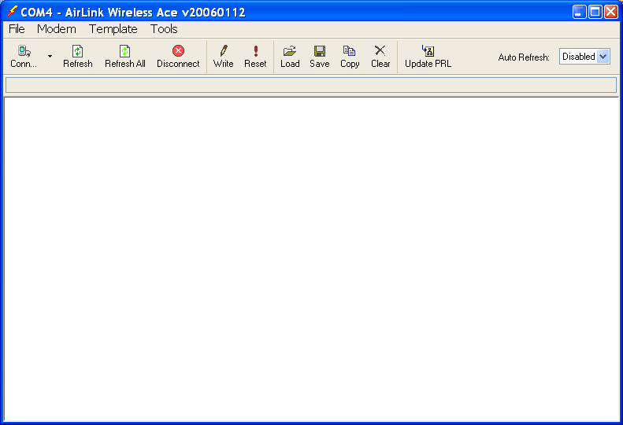

Click on “Conn” to begin. Like the Raven firmware executables, Wireless Ace 3G allows you to connect either by IP or directly through a serial cable:
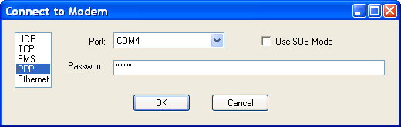

Example view of Ace Manager before upgrade:
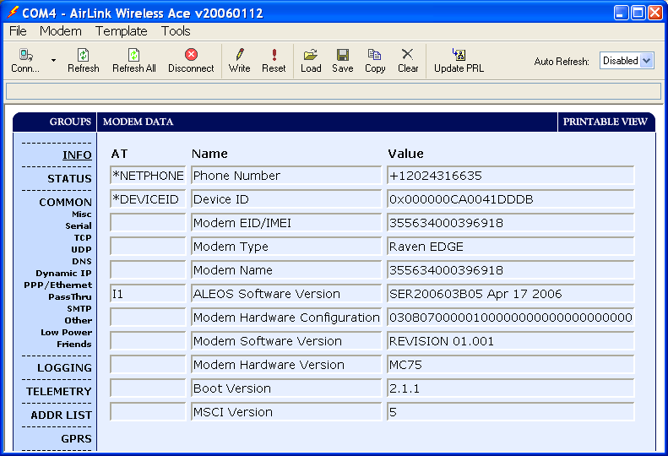

To save this INFO data in a text file, open Notebook or a text editor, and use the mouse to select, cut and paste some info:
*NETPHONE | Phone Number | +12024316635
*DEVICEID | Device ID | 0x000000CA0041DDDB
 | Modem EID/IMEI | 355634000396918
 | Modem Type | Raven EDGE
 | Modem Name | 355634000396918
I1 | ALEOS Software Version | SER200603B05 Apr 17 2006
 | Modem Hardware Configuration | 03080700000100000000000000000000
 | Modem Software Version | REVISION 01.001
 | Modem Hardware Version | MC75
 | Boot Version | 2.1.1
 | MSCI Version | 5
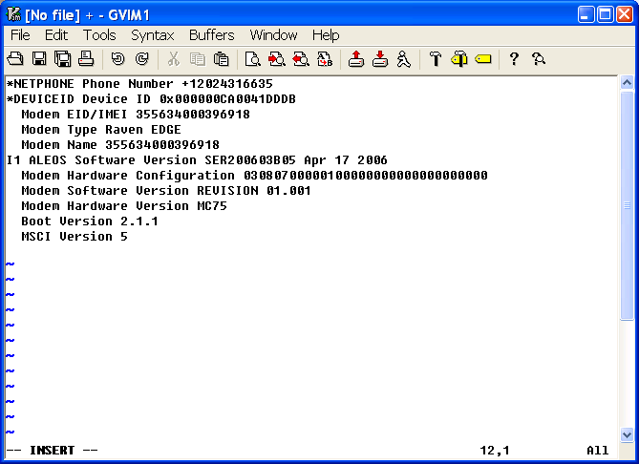

Here’s the Wireless ACE 3G Status info for this example modem:
*NETIP | Network IP | 166.213.255.223
*NETSTATE | Network State | Network Ready
*NETCHAN | Channel | 648
*NETRSSI | RSSI (dBm) | -95
*NETOP | Current Network Operator | CC 310 NC 410, 310410
+ICCID | SIM ID | 89310380106002863928
+CIMI | IMSI | 310380138227387
 | Host Mode | PPP

Note the RSSI value -95 – this tells how strong the wireless signal is. Next we’ll load a new configuration file to the connected device. Click on the “Load” symbol on the upper toolbar of Wireless Ace 3G and browse to the configuration file you want to load into the cell modem. Make sure the type (EDGE or CDMA) file matches the type of modem you are programming. For the EDGE modem, we are going to upload a Cingular file:
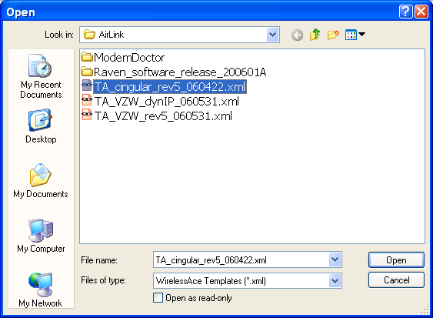

Click on “Open” to load the file into the Wireless Ace 3G program
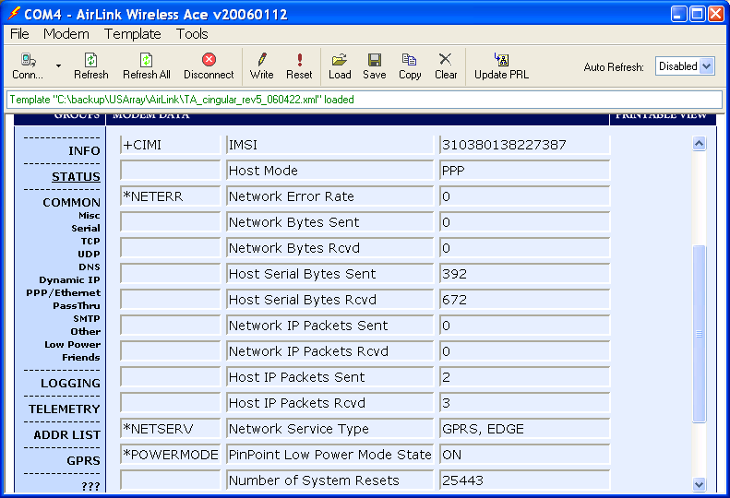

Note the text line underneath the Tool bar indicates the file was loaded:
Template "C:\backup\USArray\AirLink\TA_cingular_rev5_060422.xml" loaded. You can examine which items will be changed by clicking on all the different “Groups” sidebar tab and seeing the difference between the Value in the modem and the New Value (here’s an example for the PPP/Ethernet tab):
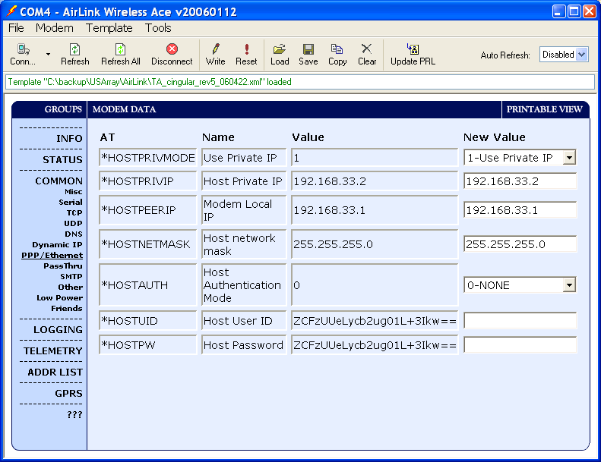

If a new value shows a blank, it is because nothing was loaded from the file for that value. Load the program into the cell modem by clicking on the “Write” symbol in the Wireless Ace 3G toolbar. After the write to the modem is completed, the text line will say: Write successful

Finally click on the “Reset” tool next to the “Write” tool and the modem will reset and reregister with the new values.

