TA Released Station Baler Downloads using EZBALER
Ver. 1.1 2008 05 06 aws
- Set PC IP to 192.168.10.222, and Subnet Mask to 255.0.0.0
- Plug in the Ethernet cable to the PC
- Connect a USB blank Lacie HD to PC, make 2 directories in the external drive: ?:\BalerData, ?:\BalerDumpLogs – where ? is the assigned drive letter.
- Inside of the ?:\BalerData directory, make 2 more directories: BVLAOU and VLAOU.
- Shut off wireless and start EZBaler Make sure it’s version 2007.337 or newer.
- Click the Lower Left “Enumerate” button on EZBaler
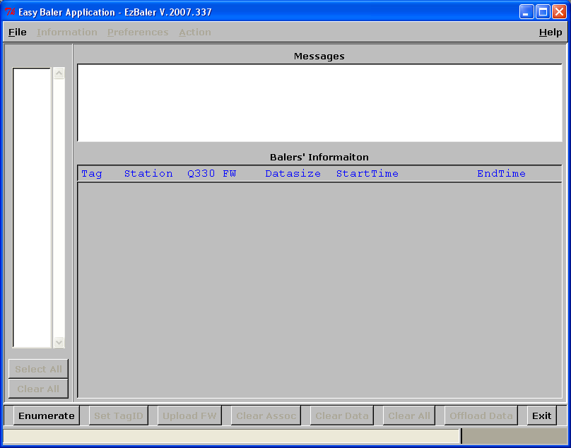
- Click the “Start Enum” button in the window below:
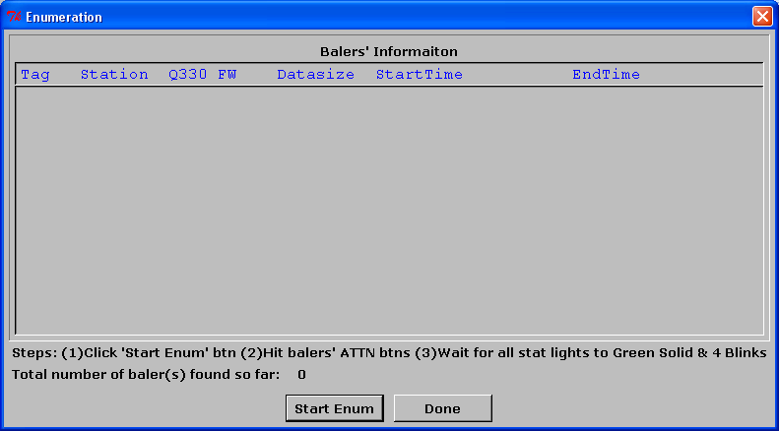
- Press the Baler Attn buttons one at a time. Wait until all balers are found on the Start Enum page and then press “Done”
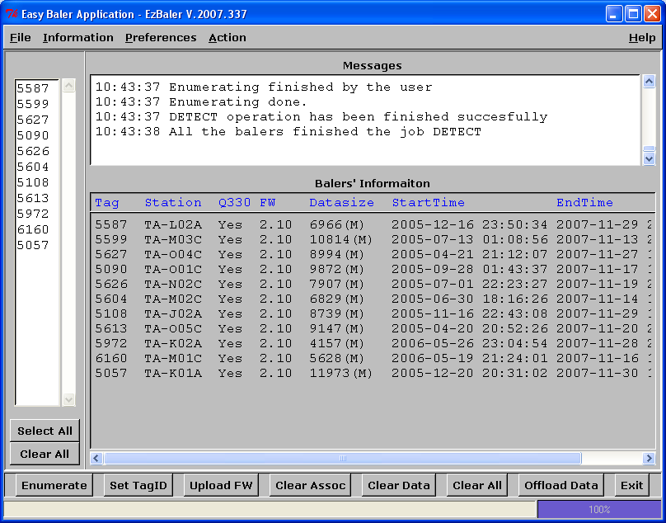
- Click the “Select All” button
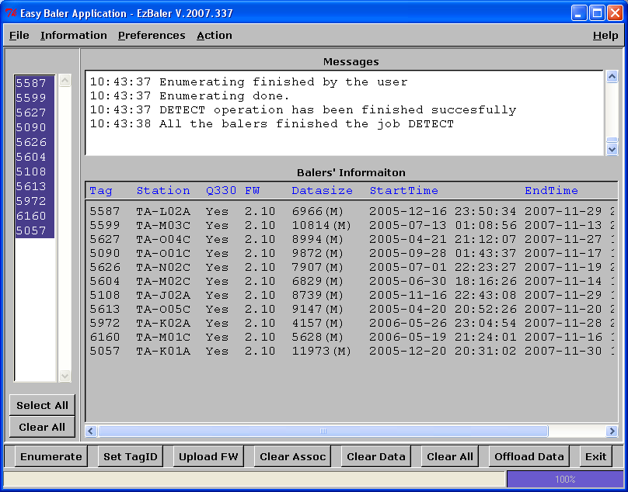
- Click on the “Preferences” tab and choose “Max Retrieving Filesize”

- Choose 1Gbytes for CD
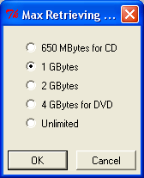

- Click the “Action” tab and choose “Retrieve VLAOU chns” or “Retrieve BVLAOU chns” or “Retrieve All data to a file” depending on which set of data you are downloading now.

- The program will open a browser window – choose the removable hard drive/BalerData/BVLAOU directory (if downloading BVLAOU data), or /BalerData/VLAOU (if downloading VLAOU data):

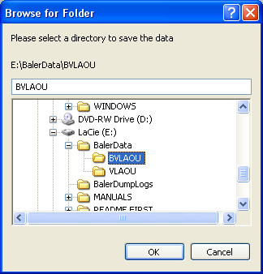

- Click “Ok”
- At this time, data begins to be dumped into the E: hard drive. Open an explorer window and check that the files are being written and are growing in size:
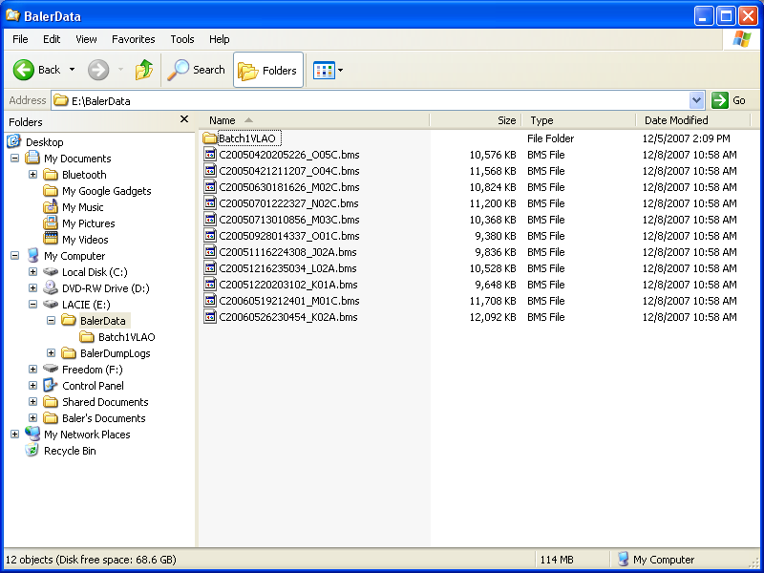

- Once all the data is dumped, click on the EZBaler window below:
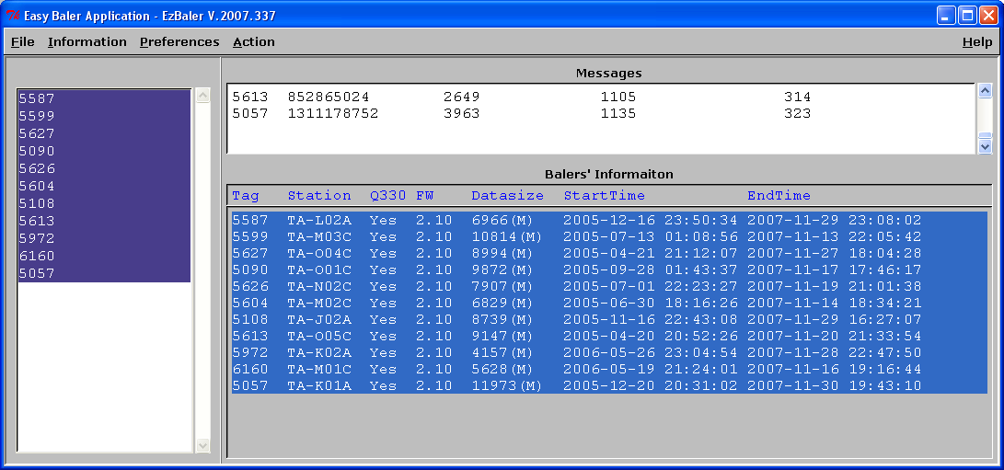
- Press the “Control”, “Alt”, and “Prnt Scrn” button all at the same time to make a copy of this page. It shows the Station, Baler tag, Data Start Time, Data End Time, and Firmware version in the baler.
- Open a Word document, and save the copy page into it by typing “Control” and “V” at the same time. The word document should look like:
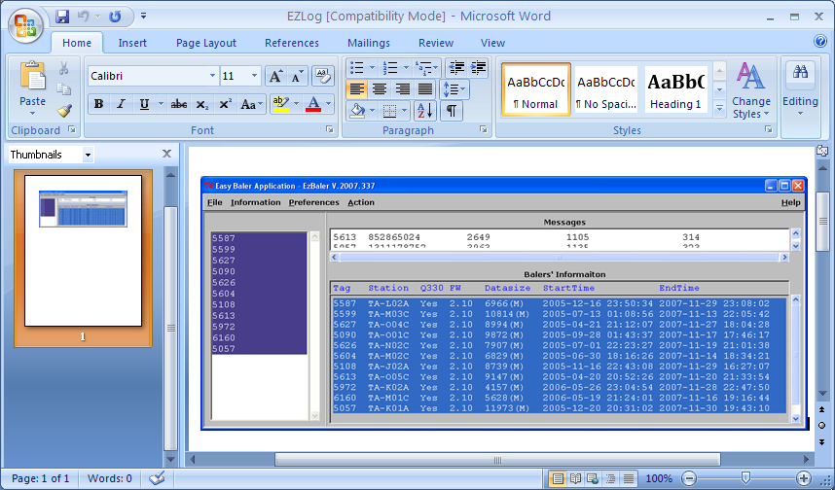
- Save this Word document onto the E:\BalerDumpLogs as filename EZLog. This is the file you will refer to when running Cimarron to check if all the data is present. Since Cimarron is only run on the VLAOU data, one dump log is sufficient – the available data time information holds for all channels of data.

