Dumping Baler Data Remotely Using the Baler Web Page

20090217 aws (ver 1.1)

This method uses the baler webpage to dump the data. You can turn on the baler through the Q330 port, or by using Willard commands. Both methods will be covered.

Using Willard to find the IP and turn on the baler:

- Start Willard:
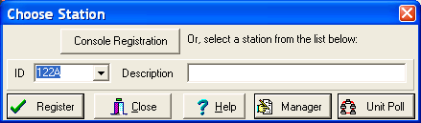

- Click the Manager Button:
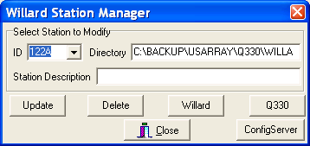

- Click the “ConfigServer” button:
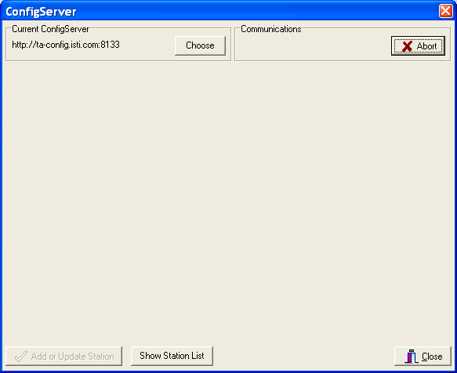

- If the current ConfigServer isn’t set to: http://ta-config.isti.com:8133, click the “Choose” button, otherwise, click the “Show Station List” and go to step 6)

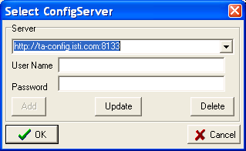

- Type in http://ta-config.isti.com:8133 into the server line; keep User Name and Password blank and click “OK”. Click “Show Station List” in the window that appears.

- After a period of time while the isti config server connects the following window will appear:

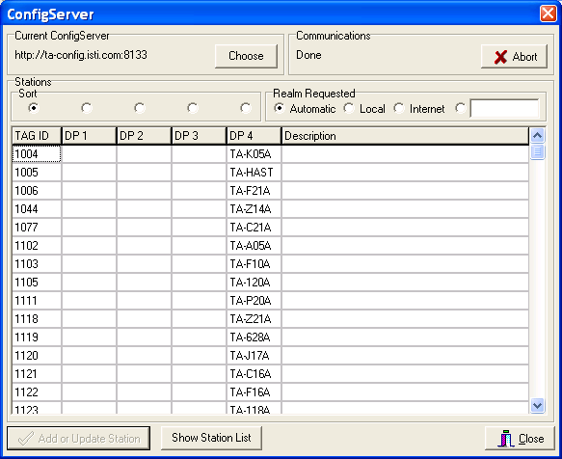

- Sort the Station codes in the DP 4 column by clicking on the radio button above DP4:
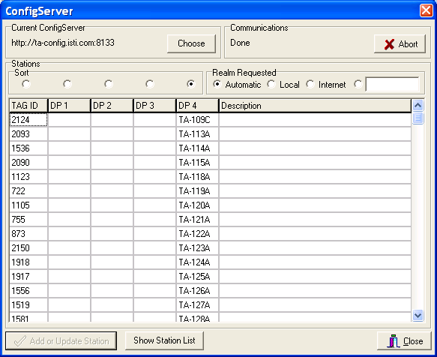

- Scroll down to the station you want data from (in this case we’ll choose E07A) and then click on that station in the DP4 column:
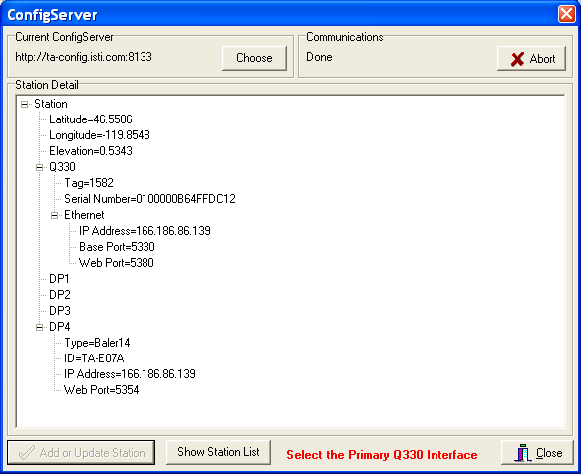

- The IP can be read in the IP Address line as being: 166.186.86.139

- Steps 11) through 20) use Willard to turn on the baler. Steps 21) through 24) use the q330 port to turn on the baler. Use one or the other method and then go to step 25) as directed.

- Click on “Ethernet” in the above ConfigServer Willard window:
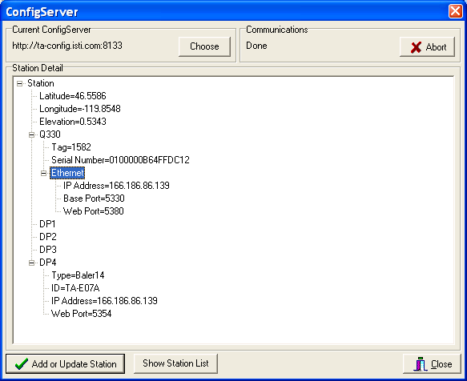
- This makes the Ethernet field turn blue. Click the activated “Add or Update Station” button.
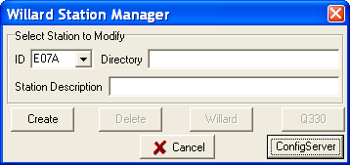

- If this station has already been connected to with Willard, the Create step will be missing. Click “Create”
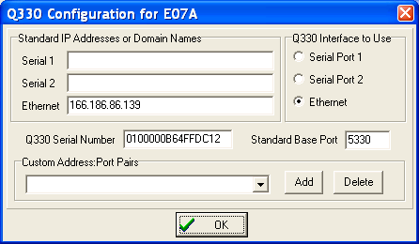

- Click “OK”
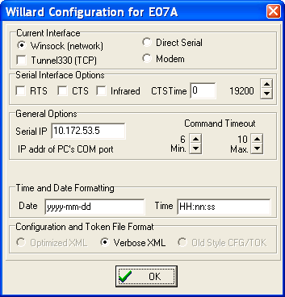
- Click “OK” again:
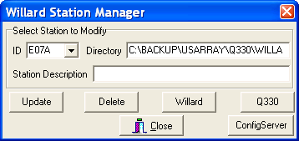

- Click “Close” to quit the Station Manager portion of Willard:
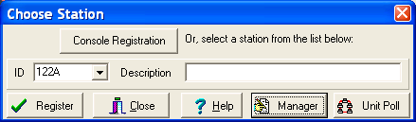

- Find E07A in the ID box, highlight it, then click “Register”
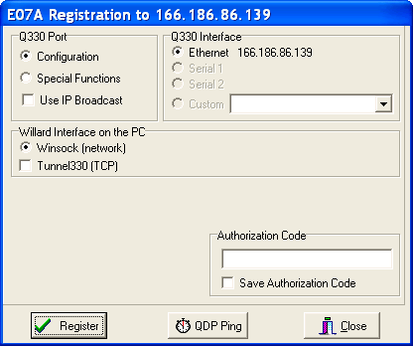

- enter “0” (zero) in the Authorization Code window, and click the Save Authorization Code Box. Then click “Register” ( I couldn’t connect to E07A, so chose E08A instead for the example that follows)
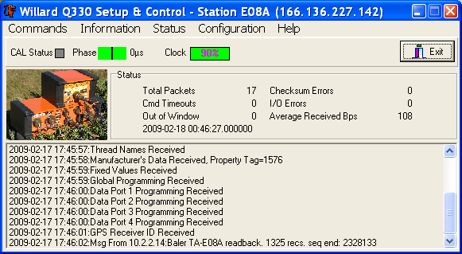

- After the station connects, the above window will show. Click on the Commands column and click on “Baler Control…” to open the following window:
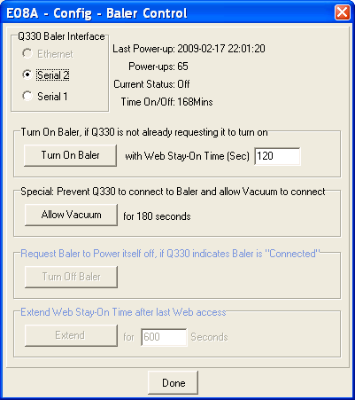

- Click “Turn On Baler” and wait 40 seconds, go to step 25).
USING the Q330 Web Page to Turn on the Baler

- Another way to turn on the baler is to use the IP gleaned from the Willard ISTI config server to open the Q330 control page. Open a browser and type in the IP followed by “: 5380”
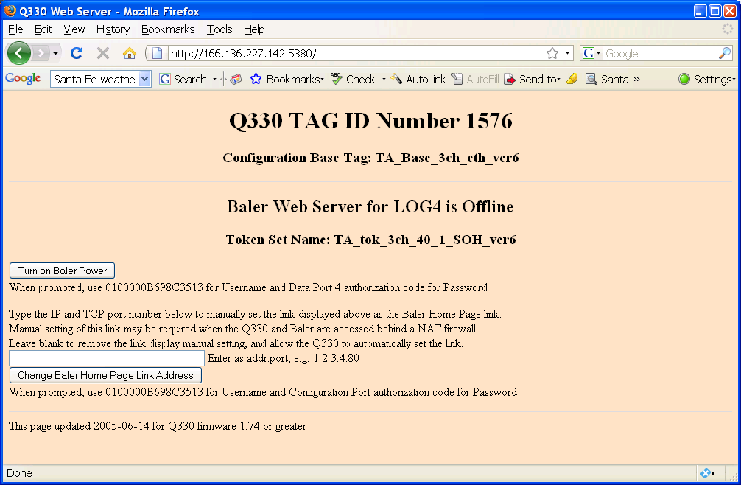

- Copy the Q330 serial number (above it is 0100000B698C3513) and click “Turn On Baler Power”

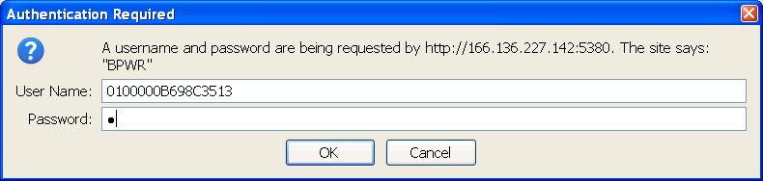

- Paste the Q330 serial number into User Name, and type “0” (zero) for the password. Then click”OK”
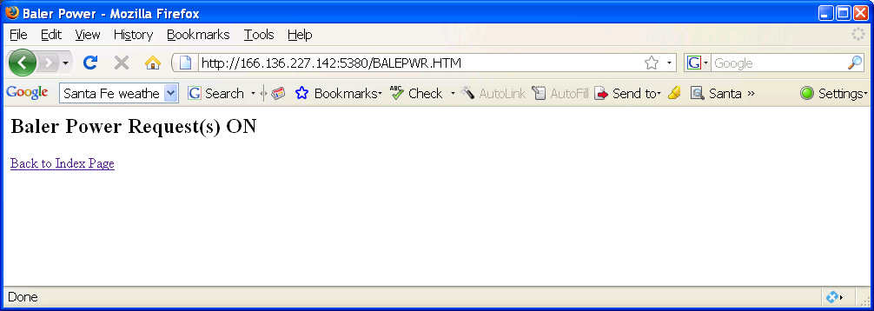

- The above window shows that the baler has been asked to turn on. Wait 40 seconds then go to step 25)

Dumping Data Using the Baler Web Page

- Type the following into the browser URL window “IP:5354” where IP is the station IP gleaned from Willard ISTI’s config server.

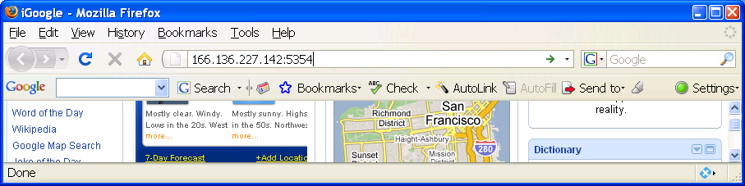

26) Then hit “Enter”
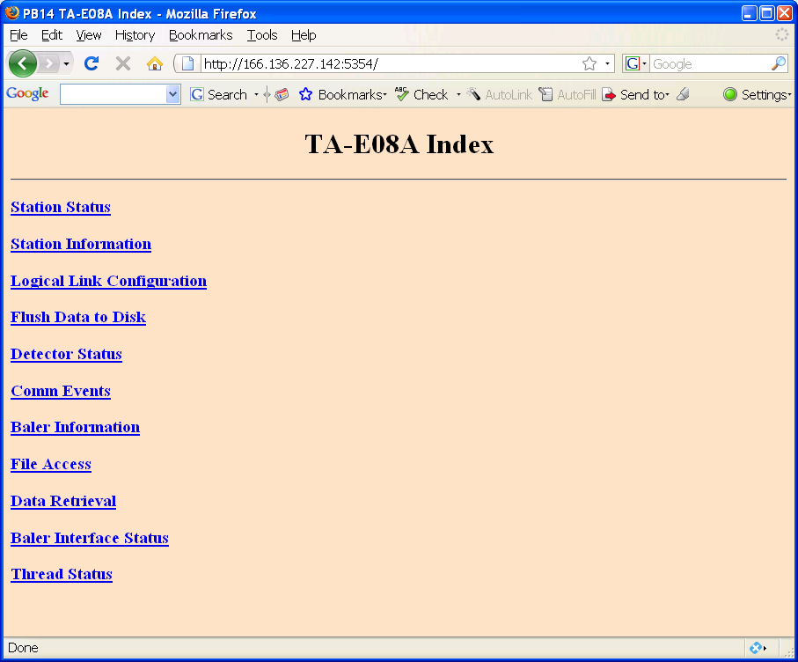

27) Click on Data Retreival
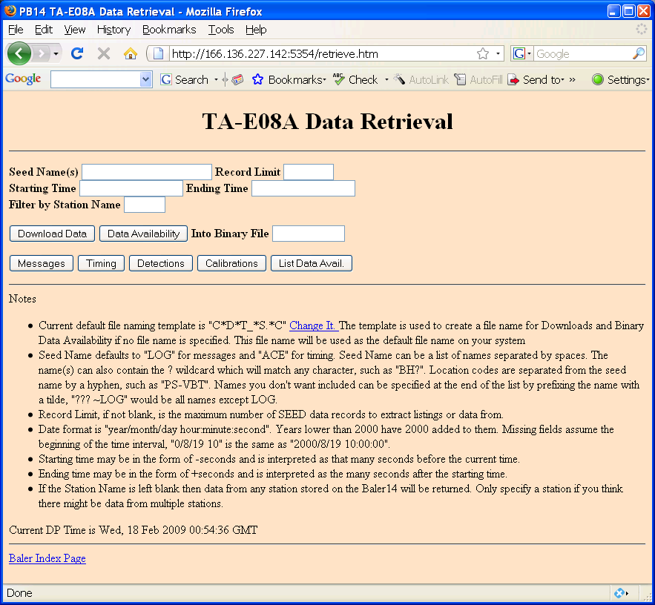

28) Enter ??? for Seed Name(s) and choose a Start time and end time (yyyy/mm/dd/ hh:mm:sec )
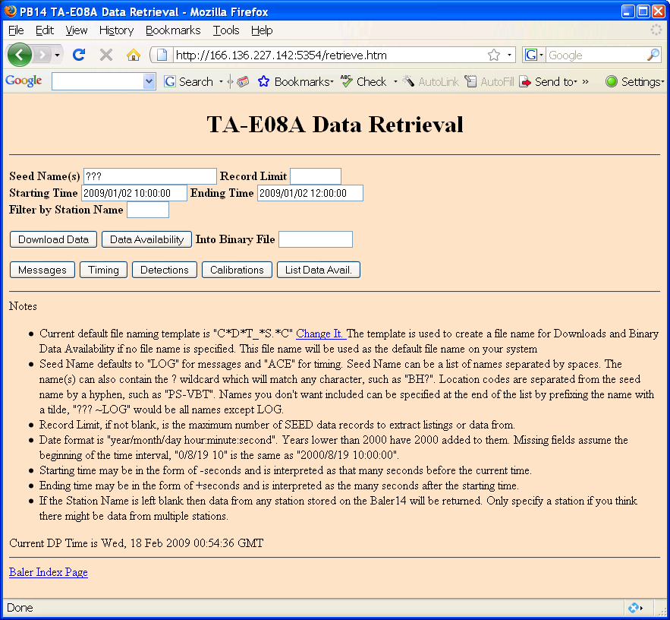

29) Click “Download Data”
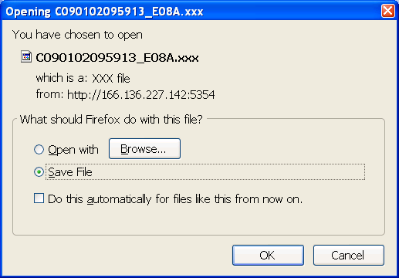

30) Choose “Save File”, then click “OK”

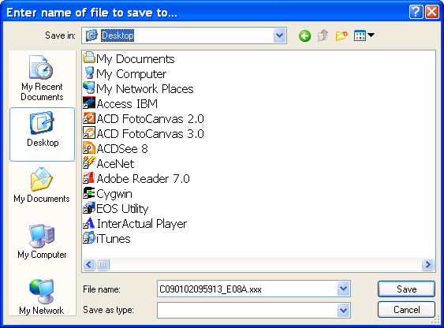

31) Browse where you want to save the file and change the default name, if desired.
Then click “Save”

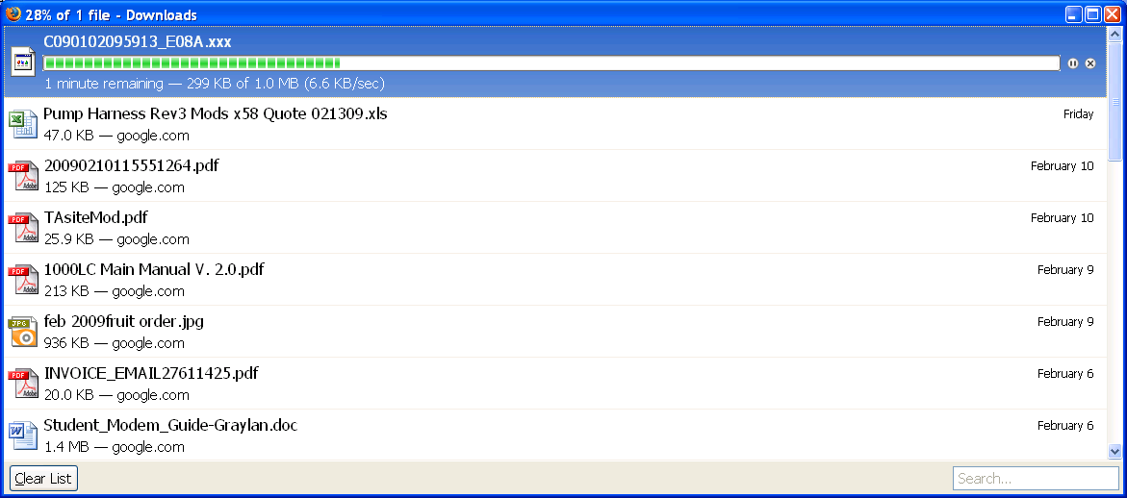

32) Depending on your browser, download progress will be displayed and you will be told when the data is saved. You’re done!

